Tables, Data Types and Constraints

Table Creation (CREATE TABLE)
A table is a collection of related data organized in rows and columns. You create a table using the CREATE TABLE statement, which defines the table's name, its columns, and the type of data each column can hold.

Syntax:
CREATE TABLE table_name (
column1 datatype constraint,
column2 datatype constraint,
...
);

Example:
Let's create a students table, mirroring the example from the introductory document.
CREATE TABLE students (
student_id SERIAL PRIMARY KEY,
first_name VARCHAR(50) NOT NULL,
last_name VARCHAR(50) NOT NULL,
email VARCHAR(100) UNIQUE NOT NULL,
faculty VARCHAR(100)
);

Table Structure and Columns
The structure of a table is defined by its columns. Each column has:
- A name (e.g., student_id, email).
- A data type (e.g., SERIAL, VARCHAR, INTEGER, DATE) that defines what kind of data it can store.
- Optional constraints (e.g., PRIMARY KEY, NOT NULL, UNIQUE) that enforce rules on the data.

Common Data Types:
- SERIAL: Auto-incrementing integer (perfect for surrogate primary keys).
- INTEGER, BIGINT: Whole numbers.
- VARCHAR(n): Variable-length character string with a maximum length of n.
- TEXT: Variable-length character string without a set limit.
- BOOLEAN: True or false values.
- DATE, TIMESTAMP: Date and time values.

Common Constraints:
- PRIMARY KEY: Uniquely identifies each row in a table (implies UNIQUE and NOT NULL).
- NOT NULL: Ensures a column cannot have a NULL value.
- UNIQUE: Ensures all values in a column are different.
- CHECK: Ensures all values in a column satisfy a specific condition (e.g., CHECK (grade >= 0 AND grade <= 100)).
- FOREIGN KEY: Enforces a link to the primary key in another table.

Dropping Tables (DROP TABLE)
The DROP TABLE statement permanently removes a table and all its data from the database. Use this command with extreme caution, as the action is irreversible.

Syntax:
DROP TABLE table_name;

Example:
DROP TABLE test_table;

To avoid errors if the table might not exist, use IF EXISTS:
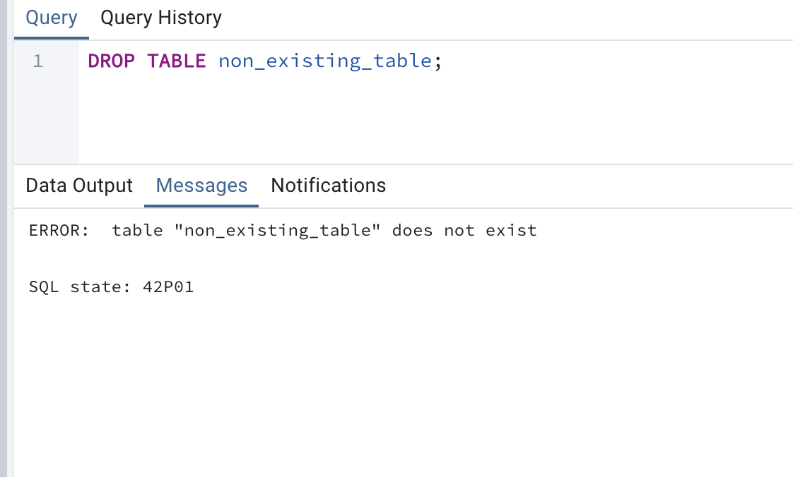
DROP TABLE IF EXISTS test_table;
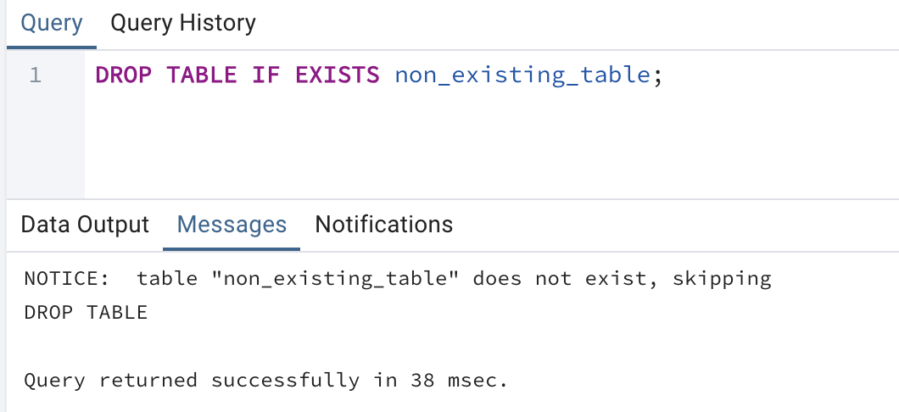

Altering Table Structure (ALTER TABLE)
The ALTER TABLE statement is used to modify the structure of an existing table without dropping and recreating it. This is essential for schema evolution.

Common Use Cases and Syntax:
- Adding a Column
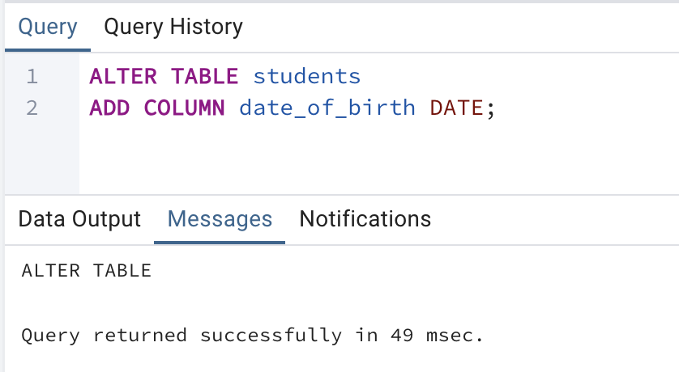
- Dropping a Column
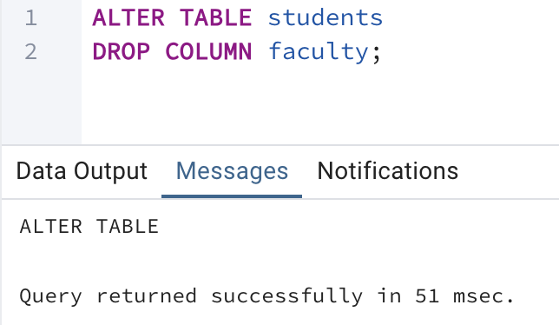
- Changing a Column's Data Type
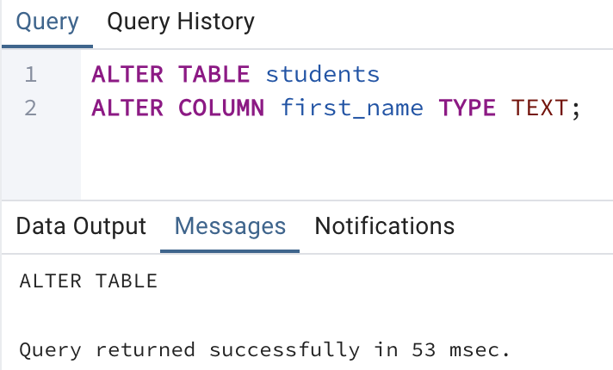
- Adding a Constraint
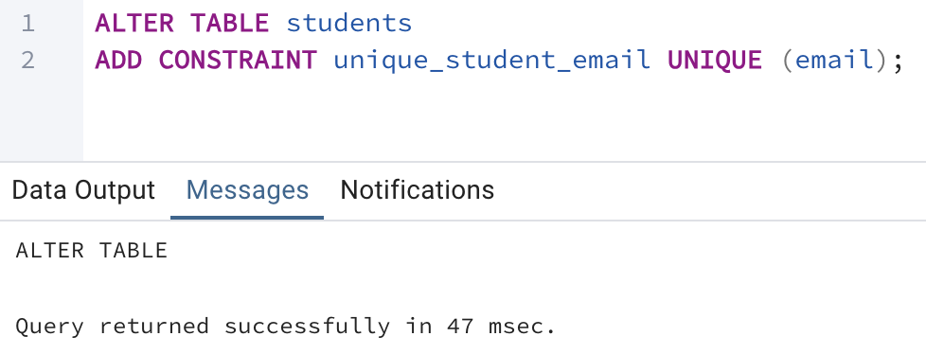
- Renaming a Column or Table
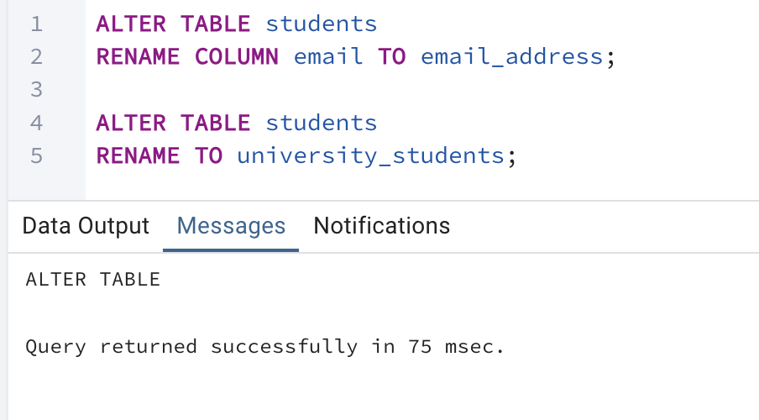

Table Naming Conventions
Following consistent naming conventions makes your database schema much more readable and maintainable. The conventions from the introductory document are standard.
- Use descriptive, meaningful names: students, course_enrollments, instructors.
- Use lowercase and underscores: course_id instead of courseID or CourseId.
- Use singular nouns for table names: Prefer student over students. (Note: While students was used in the examples for clarity, student is a very common convention. Both are acceptable, but consistency is key).
- Primary key column: Often simply id or tablename_id (e.g., student_id).
- Foreign key column: Should typically match the name of the primary key column it references (e.g., student_id in the enrollments table references student_id in the students table).

Temporary Tables
Temporary tables are tables that are automatically dropped at the end of a database session or the current transaction. They are isolated from other sessions and are useful for storing intermediate results during complex data manipulation.

Syntax:
CREATE TEMP TABLE temp_table_name (
column1 datatype,
...
);

